Terraform Task

**Name:Shaik Khaja Basha**

**Batch : Batch 11**

**Date : 21.07.2025**

**Task : Injecting Variables for diff resources of random**

1. **inject values from different modes to different resources of random**

**ans:**

1. use different sources of input values (CLI, env vars, tfvars, auto.tfvars, default, etc.)
2. inject those values into **different random resources** like random_pet, random_string, and random_id.

Inject values from the **different input modes**, each targeting to a **different resource**:

* **Decleration of Variables:**

variable "pet_prefix" {

description = "Prefix for random_pet"

type = string

default = "defaultpet"

}

variable "id_prefix" {

description = "Prefix for random_id"

type = string

}

variable "string_length" {

description = "Length for random_string"

type = number

}

variable "shuffle_input" {

description = "List for random_shuffle"

type = list(string)

}

variable "uuid_keepers" {

description = "Value used to trigger regeneration"

type = string

}

variable "password_length" {

description = "Password length"

type = number

}

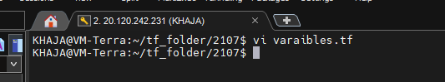

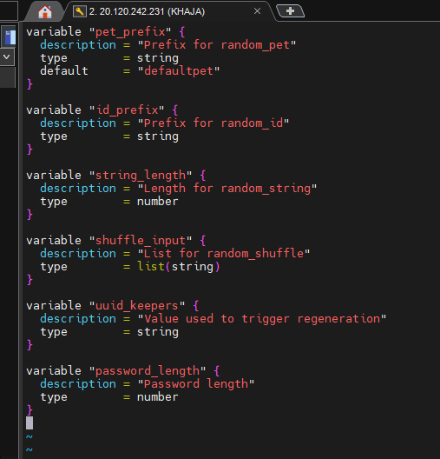

I will be assigning output variable in the same file variable.tf

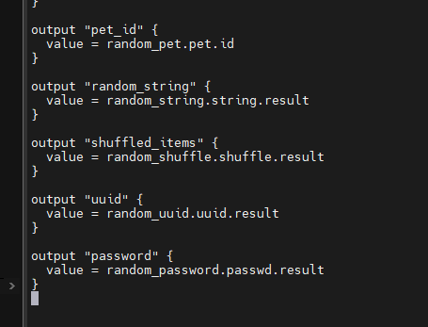

Know create Resource Definitions

# 1. From default

resource "random_pet" "pet" {

prefix = var.pet_prefix

}

# 2. From terraform.tfvars

resource "random_id" "id" {

prefix = var.id_prefix

byte_length = 4

}

# 3. From adi.auto.tfvars

resource "random_string" "string" {

length = var.string_length

special = false

}

# 4. From env variable

resource "random_shuffle" "shuffle" {

input = var.shuffle_input

result_count = 2

}

# 5. From CLI -var

resource "random_uuid" "uuid" {

keepers = {

version = var.uuid_keepers

}

}

# 6. From CLI -var-file

resource "random_password" "passwd" {

length = var.password_length

special = true

}

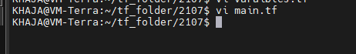

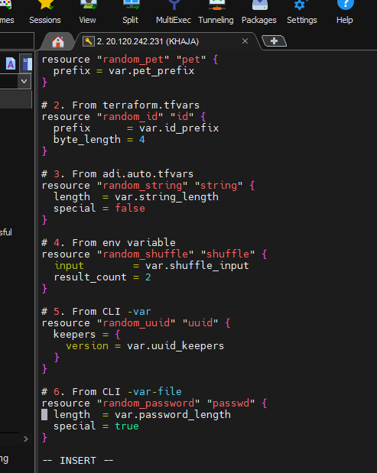

* **terraform.tfvars – Value for random_id**

**id_prefix = "idtfvars"**

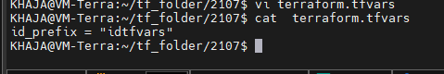

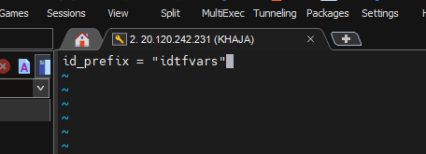

* **shaik.auto.tfvars – Value for random_string**

**string_length = 10**

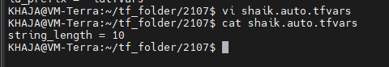

* **Export Env Variable for random_shuffle**

export TF_VAR_shuffle_input='["apple", "banana", "cherry", "dates"]'



* **Create CLI -var-file for random_password**

prod.properties

password_length = 12

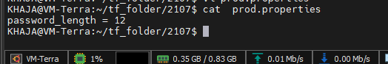

* **Run Terraform Apply**

terraform init

terraform apply \

-var="uuid_keepers=fromcli" \

-var-file="prod.properties"

